docker-compose.yml

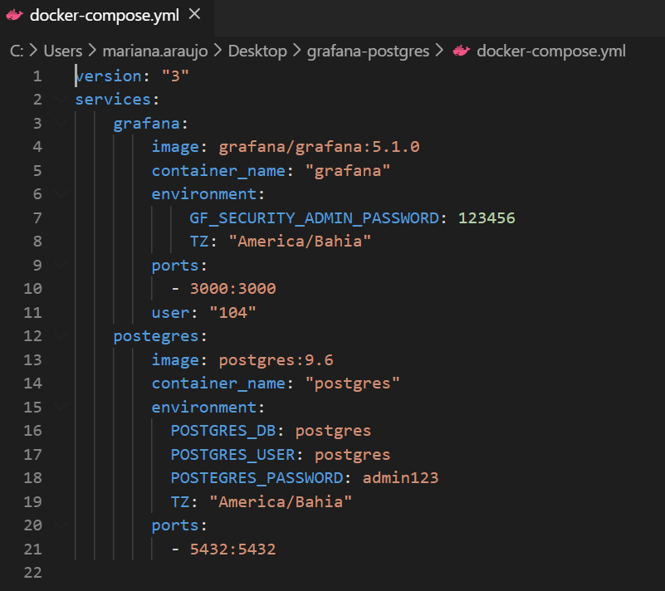

Containers:



Grafana – Configuração BD:

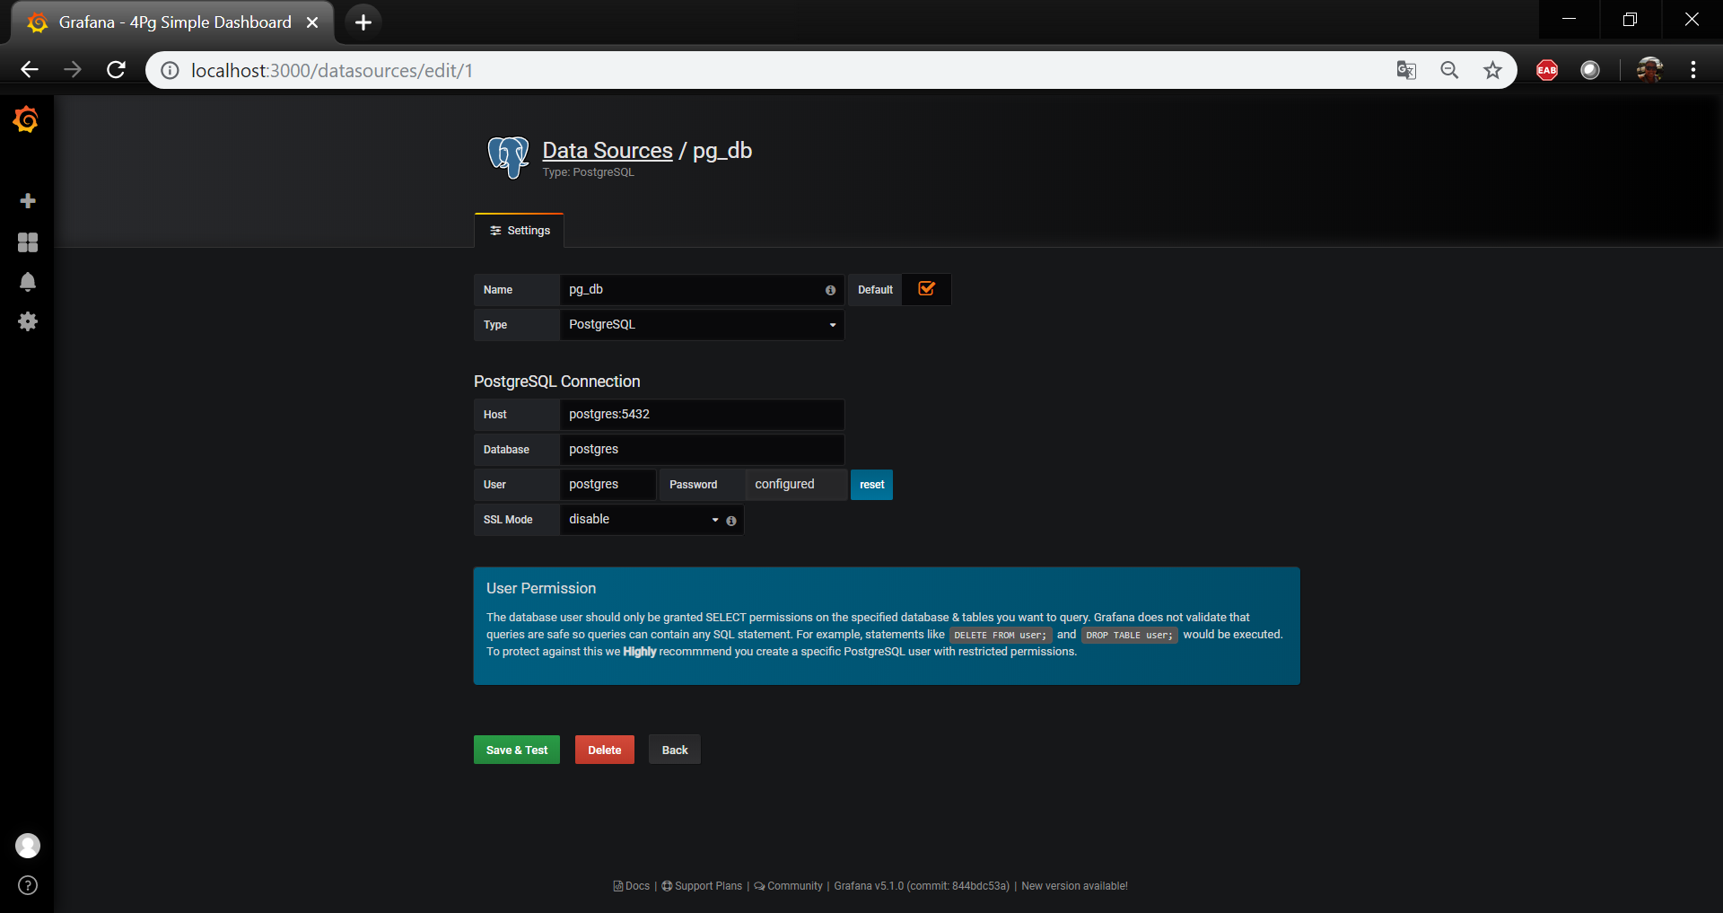

Grafana – Import Dashboard (Dashboard utilizado: <https://grafana.com/grafana/dashboards/11056>):

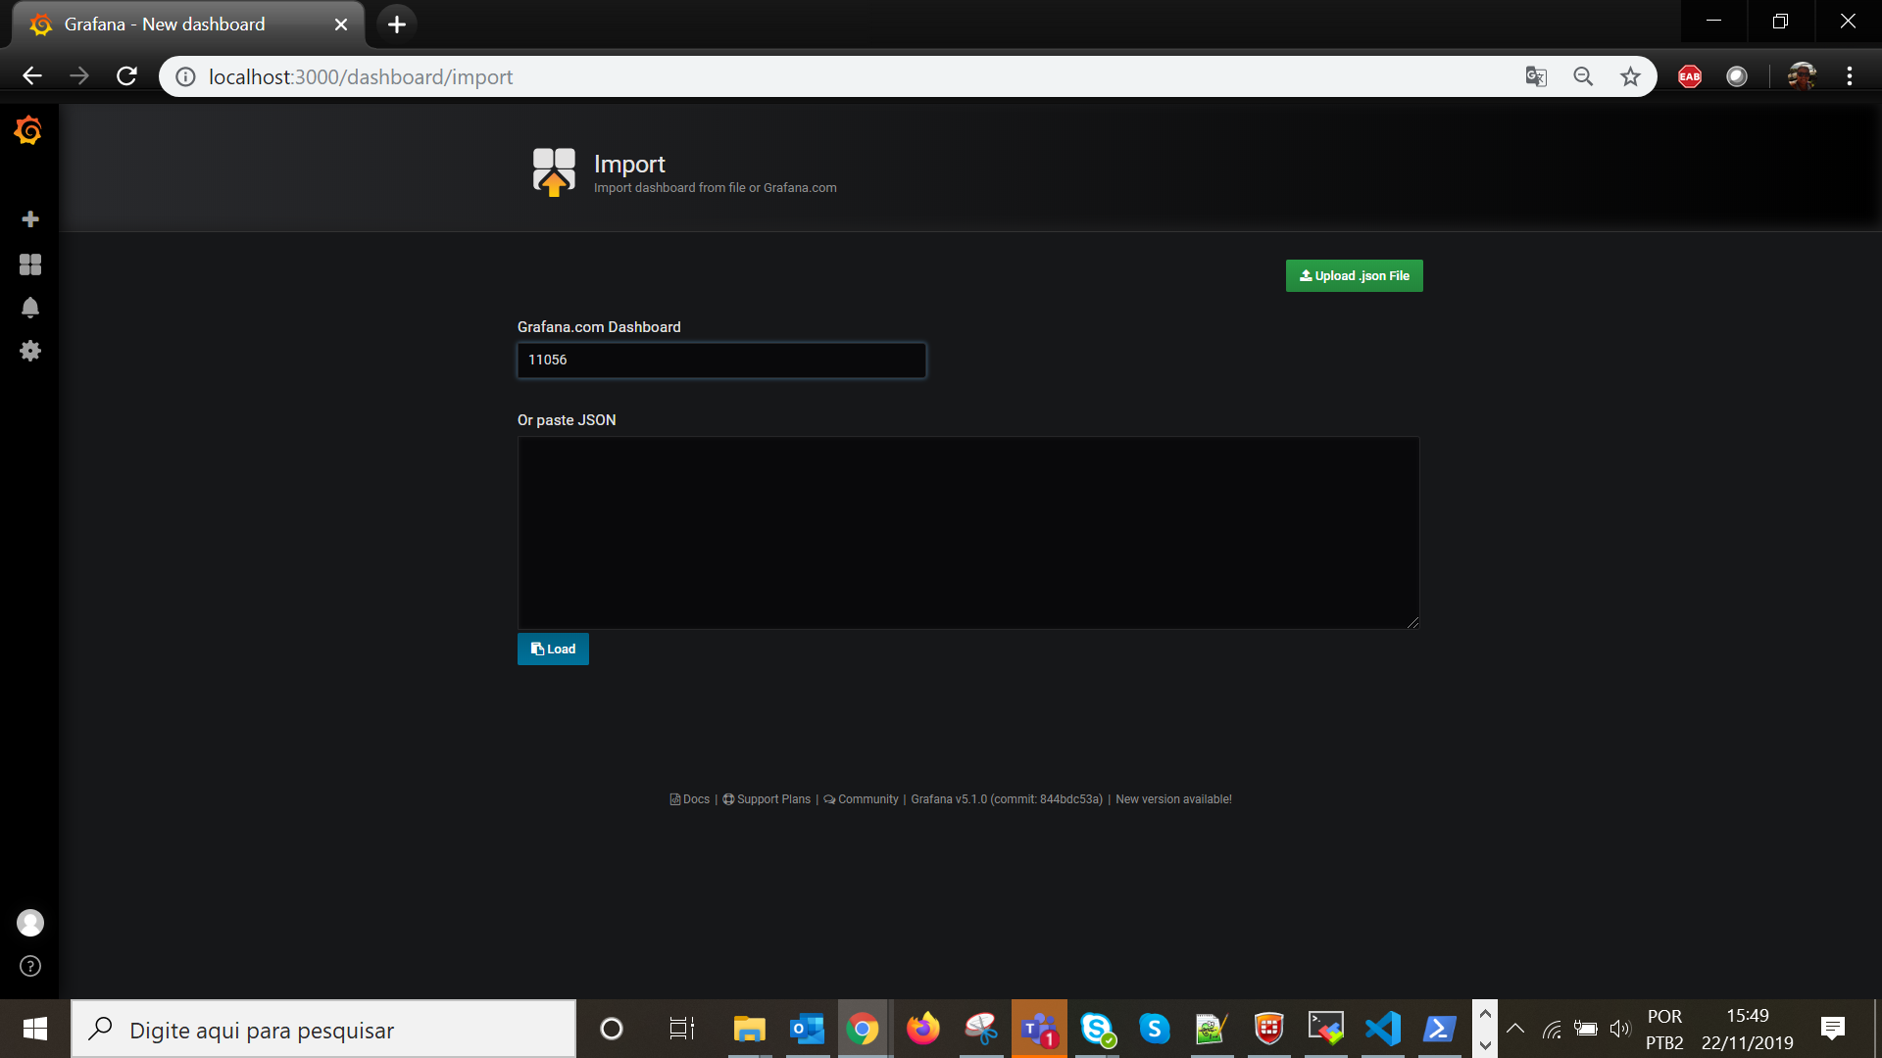

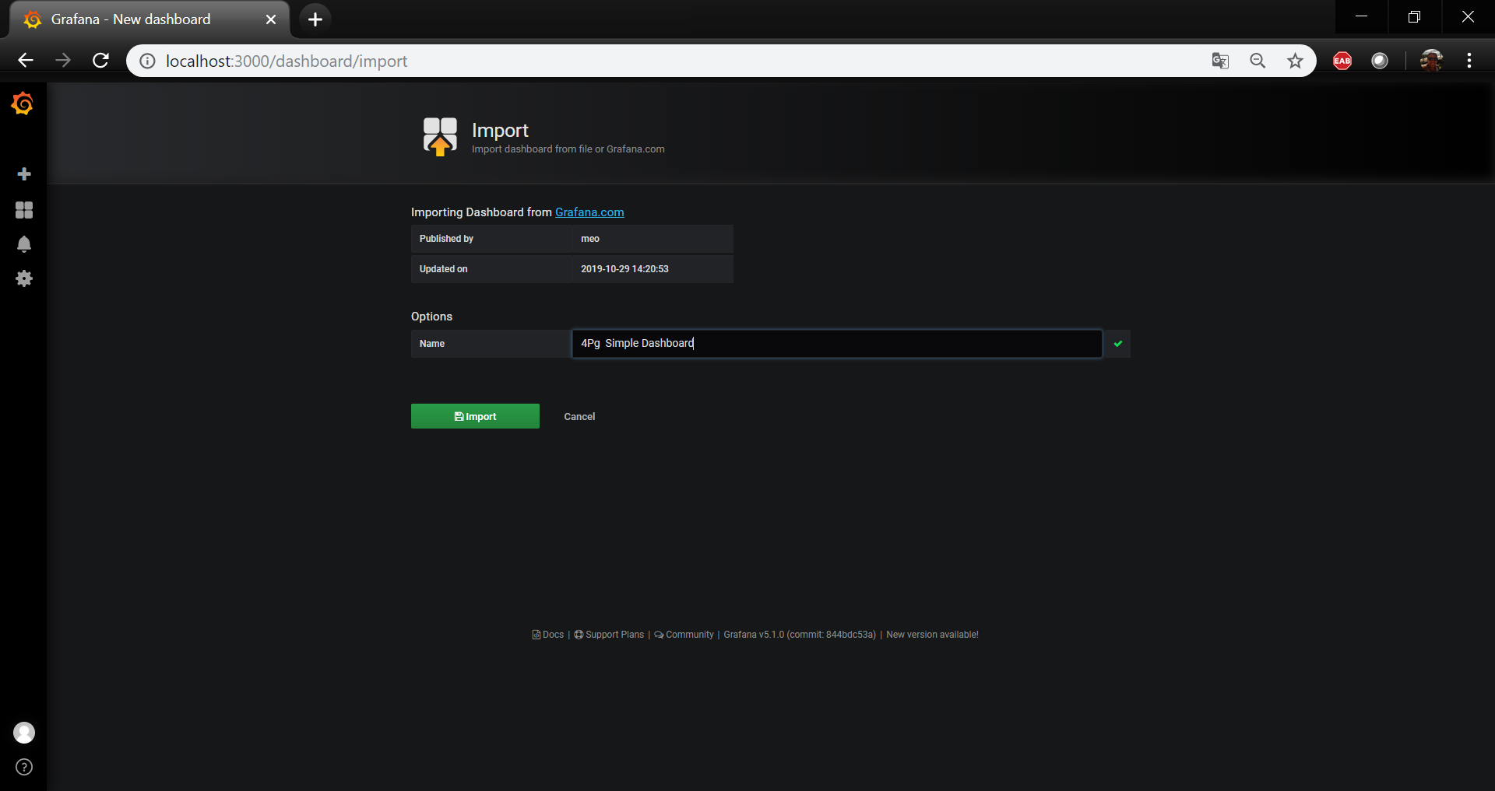

Grafana – Dashboard

